Breakout Project: Guidelines and Installation Manual
This document provides instructions on setting up the training environment (ALE/Breakout-v5) for the Breakout project. To ensure a consistent starting point for evaluation, the baseline environment is strictly fixed. However, students are free to use additional options (e.g., modifying parameters for comparison) and various learning tools such as Stable Baselines3, CleanRL, or Ray Rllib.
Attachments:
- Guide to Breakout Environment.docx
- requirements.txt
- verify_env.ipynb

Table of Contents (Ctrl+Click to follow link)
- Introduction to Gymnasium and ALE/Breakout-v5
- Installing Anaconda
- Creating a Virtual Environment
- Installing Required Packages
- Installing PyTorch (for GPU Support)
- Installation Verification
- Frequently Asked Questions (FAQ)

1. Introduction to Gymnasium and ALE/Breakout-v5
1.1 What is Gymnasium?
Gymnasium is the maintained fork of OpenAI Gym, serving as the standard platform for developing and testing reinforcement learning (RL) algorithms. It provides a wide range of environments through a standardized API, allowing users to easily modify environments and conduct performance benchmarks.
Official Documentation:
https://gymnasium.farama.org/, https://github.com/Farama-Foundation/Gymnasium

1.2 ALE/Breakout-v5
The Arcade Learning Environment (ALE) is a simulator that provides a suite of Atari 2600 games as reinforcement learning environments. Breakout is one of the most widely used benchmarks within this suite. It features simple rules: the agent must control a paddle to bounce a ball and break the bricks located at the top of the screen.
Official Documentation:
https://ale.farama.org/environments/breakout/


The training environment for this project is ALE/Breakout-v5, and all experiments must be conducted based on the following configurations:
import gymnasium as gym
import ale_py
gym.register_envs(ale_py)

env = gym.make(
"ALE/Breakout-v5",
frameskip=1,
repeat_action_probability=0.0,
full_action_space=False,
)

This configuration is equivalent to the BreakoutNoFrameskip-v4 environment from the original OpenAI Gym (the predecessor to Gymnasium). Most research papers and studies have been conducted using this specific environment, and many GitHub repositories or codebases are built and tested based on these settings.
As Gym updated to Gymnasium, the setup method changed to ALE/Breakout-v5. By applying the settings below, you can reproduce the classic environment.

Key Parameters and Their Meanings:
- frameskip=1: Disables the internal frameskip of the environment. This determines how many frames the environment progresses per step. A value of 1 means 1 frame per step.
- Note: The default for v5 is 4, which repeats the same action for 4 frames. This typically requires additional preprocessing, such as max-pooling over the 4 frames.
- repeat_action_probability=0.0: Specifies the probability that the action from the previous step will be reused, regardless of the new action inferred by the agent.
- Note: The default for v5 is 0.25 (a 25% chance of repeating the previous action).
- full_action_space=False: In Breakout, the action space consists of 4 inputs: NOOP, FIRE, RIGHT, and LEFT. However, the original Atari console supports 18 different inputs. This option determines whether to use the simplified 4-action set or the full 18-action set.
- Note: The default for v5 is False, which uses the 4 basic actions.

For more detailed information on these and other parameters, please refer to the attached "Breakout Environment Guide" file. While you are free to change these parameters for your own experiments, you must clearly state any modifications in your final report.

2. Installing Anaconda
What is Anaconda?
Anaconda is an open-source platform designed for data science and machine learning. It provides an easy way to manage virtual environments and simplifies the installation and maintenance of various frameworks and libraries. By using Anaconda, you can prevent dependency conflicts between different projects.

Download: Visit the official Anaconda website and download the installer that matches your operating system.
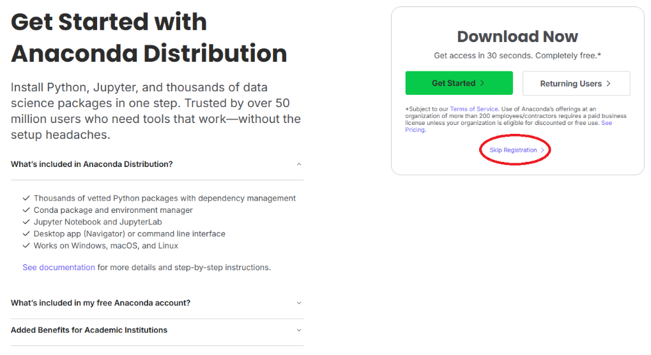
Skip Registration: You can click "Skip registration" to download the installer directly without logging in.
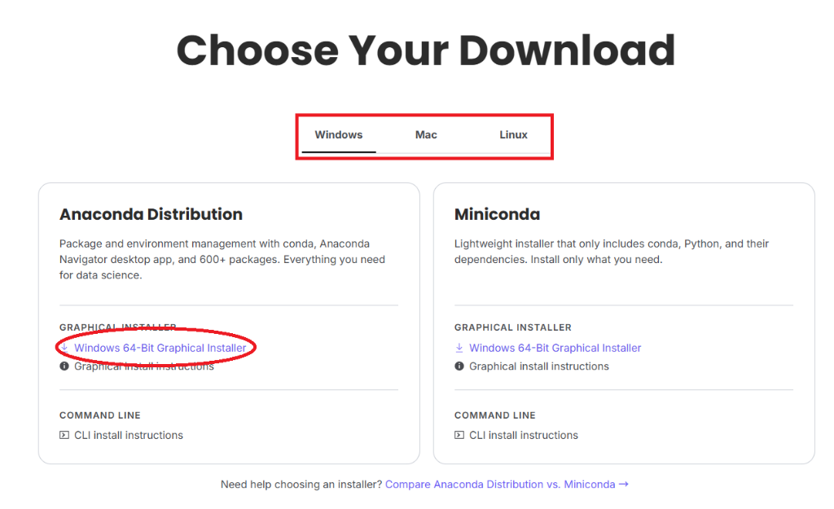
Choose Your Version: Ensure you install the version compatible with your environment. We recommend installing the full "Anaconda" distribution rather than "Miniconda" for this project.

How to Access: Once the installation is complete, you can manage your environments using either a Command Line Interface (CLI) or a Graphical User Interface (GUI):
- Anaconda Prompt (Windows) or Terminal (macOS / Linux): Use this for console-based commands (recommended).
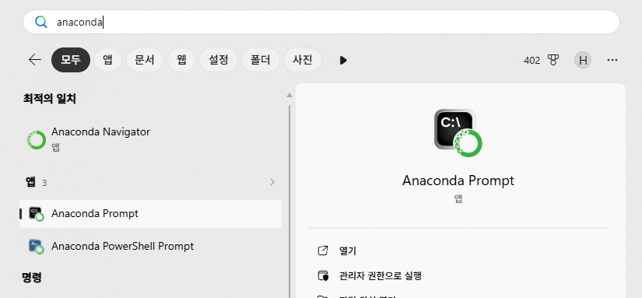
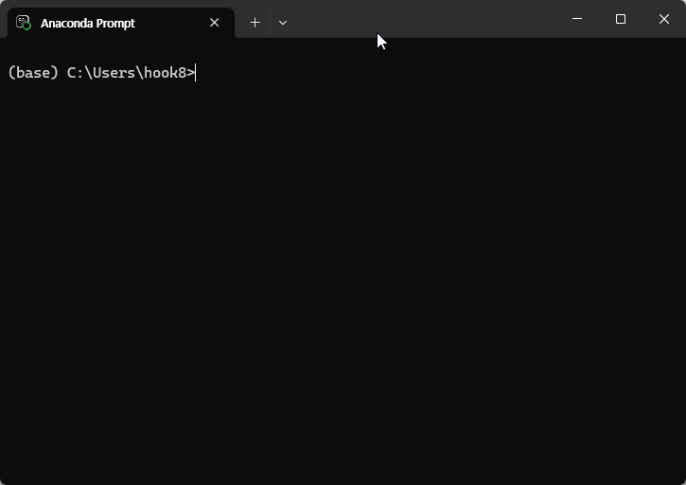
- Anaconda Navigator: A desktop GUI for managing packages and environments.
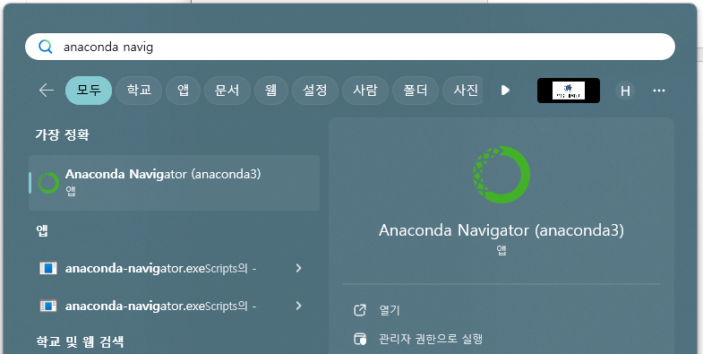
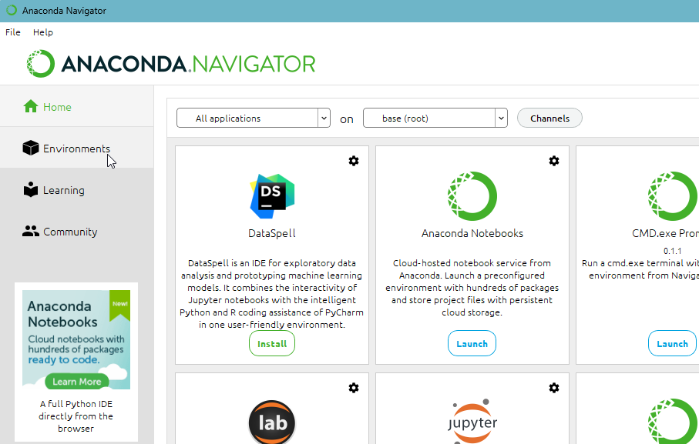

3. Creating a Virtual Environment
3.1 Creating an Environment via Console Commands
Run the following commands in your Anaconda Prompt or Terminal:
conda create -n breakout python=3.11 -y
conda activate breakout
- breakout is the name of the virtual environment (you may choose a different name if you prefer).
- Python 3.11 is highly recommended (versions 3.10 through 3.12 are also compatible).
If your command prompt changes to start with (breakout) ... after activation, the environment has been successfully loaded.

3.2 Creating an Environment via Anaconda Navigator (GUI)
If you prefer using a graphical interface instead of the command line, follow these steps:
- Launch Anaconda Navigator: Open the application and click on the "Environments" tab on the left sidebar.
- Create a New Environment: Click the "Create" button at the bottom of the list.
- Configure Settings:
  - Name: Enter a name for your environment (e.g., breakout).
  - Python Version: Python 3.11 is recommended (versions 3.10 to 3.12 are also supported).
- Open Terminal: Once the environment is created, select it from the list, click the arrow button (Play icon) next to the environment name, and select "Open Terminal". This will open a console window with the environment already activated.
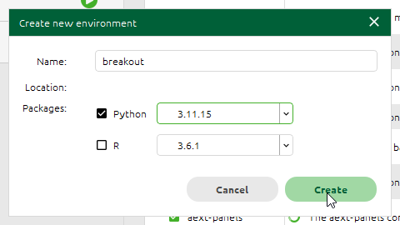
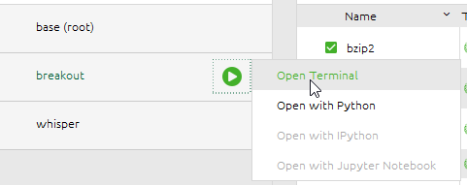

4. Installing Required Packages
Perform these steps in the console where your virtual environment is activated. First, verify that the environment name in parentheses—(breakout) or your chosen name—is correct to ensure you are working within the right environment.
If you are not currently in the correct environment, switch to it using the following command:
conda activate breakout

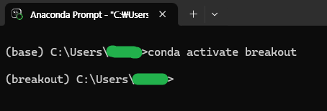

4.1 Core Packages (Standard for All Students)
To ensure that every student starts from the same environment, the following three packages must be fixed to these specific versions. This is critical for maintaining consistency during evaluation.
- gymnasium[atari] : 1.3.0
- ale-py : 0.11.2
- autorom[accept-rom-license] : 0.6.1

Choose one of the following two methods to install the required packages:

Method A) Using the attached requirements.txt
Navigate to the folder containing the requirements.txt file while your virtual environment is active, then run:
pip install -r requirements.txt
AutoROM --accept-license

Method B) Entering commands directly
If you prefer to install the packages manually, execute the following commands in order:
pip install "gymnasium[atari]==1.3.0" "ale-py==0.11.2" "autorom[accept-rom-license]==0.6.1"
Important: After installation, you must run the following command to download the Atari ROMs (this includes accepting the license). You only need to run this once:
AutoROM --accept-license

4.2 Additional Packages (Optional / Student Choice)
In addition to the three core packages mentioned above, you are free to install any Reinforcement Learning (RL) libraries or tools required for your project.

Examples include:
# Using Stable-Baselines3:
pip install "stable-baselines3[extra]"
# Adding logging tools only (e.g., TensorBoard):
pip install tensorboard
You are welcome to use any other packages as needed. However, please ensure that you clearly list all additional packages used in your final report.

5. Installing PyTorch (for GPU Support)
Most RL libraries use PyTorch as their backend. If you have a compatible GPU, installing the GPU-supported version of PyTorch will significantly accelerate the training process.

5.1 Checking the Maximum Supported CUDA Version
If you have an Nvidia GPU, check your system's compatible CUDA version by running the following command in your terminal or prompt:
nvidia-smi

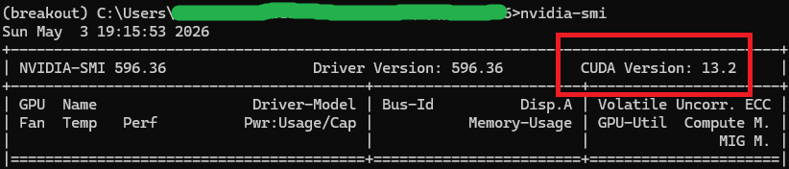
Check the "CUDA Version: " displayed at the top right of the output. Please note that this does not necessarily represent the version of CUDA currently installed; rather, it indicates the maximum CUDA version supported by your current GPU driver.

5.2 PyTorch Installation Commands
Visit the official PyTorch website to generate an installation command tailored to your system specifications.
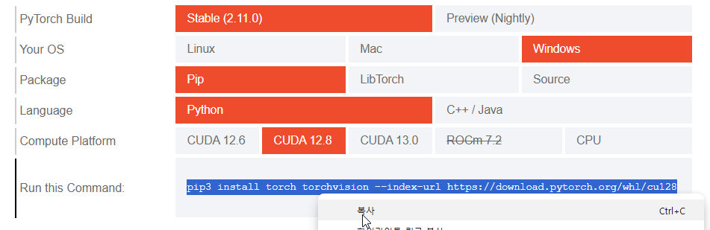
- Version Recommendation: Different packages may recommend different CUDA versions. For optimal stability, we generally recommend CUDA 12.8 (as of 2026).
- Installation: Run the command obtained from the official site in your terminal.
- Verification: Before executing the command, double-check that your console is currently active in the correct environment (e.g., the name (breakout) should be visible).
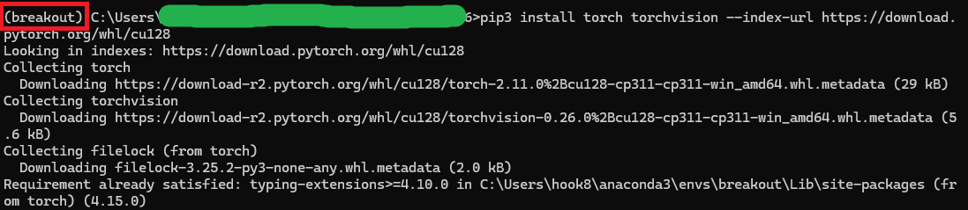

6. Installation Verification
Once the installation is complete, use the provided verify_env.ipynb script to confirm that the environment is set up correctly.:
If all steps pass with an "OK" status as shown below, your environment is ready.

[1/4] Gymnasium import ... OK (version 1.3.0)
[2/4] ale-py import + ALE registration ... OK (version 0.11.2)
[3/4] ALE/Breakout-v5 environment creation ... OK (action_space=Discrete(4))
[4/4] Random play 100 steps ... OK (Cumulative reward=0.0)

✅ All checks passed. You are ready to start training!

If you encounter any issues during this verification process, please refer to the FAQ section below.

7. Frequently Asked Questions (FAQ)

Q1. Namespace ALE not found. Have you installed the proper package for ALE?
- Cause: Starting from Gymnasium version 1.0.0, the automatic registration of ale-py has been removed. Even if ale-py is correctly installed, you must explicitly call the registration function in your code.
- Solution: Add the following lines to the top
import gymnasium as gym
import ale_py
gym.register_envs(ale_py)

Q2. ImportError: cannot import name 'AutoresetMode' from 'gymnasium.vector'
- Cause: This error typically occurs when there is a version mismatch between ale-py 0.11.x and gymnasium (specifically when gymnasium is below version 1.1).
- Solution: Update your gymnasium version to the one required for this project.
pip install -U "gymnasium>=1.1"
The project's recommended version settings (fixing gymnasium==1.3.0) will prevent this issue from occurring.

Q3. module 'gymnasium.wrappers' has no attribute 'GrayScaleObservation'
- Cause: In Gymnasium 1.x, some wrapper names have been updated or renamed for consistency.
  - GrayScaleObservation → GrayscaleObservation (Note the lowercase 's')
  - FrameStack → FrameStackObservation
- Solution: Update the names in your code to the new versions. For compatibility across both 0.29 and 1.x versions, you can use the following pattern:
GrayscaleObs = (
getattr(gym.wrappers, "GrayscaleObservation", None)
or gym.wrappers.GrayScaleObservation
)
FrameStackObs = (
getattr(gym.wrappers, "FrameStackObservation", None)
or gym.wrappers.FrameStack
)

Q4. "AutoROM fails to download ROMs / License Error"
- Solution: Reinstall the related package and try again. Run the following commands in order:
pip install --upgrade "autorom[accept-rom-license]==0.6.1"
AutoROM --accept-license

